**Installing Docker on Windows 2016 Server**

***//In Mircosoft Windows Docker Support Microsoft Windows 2016 Onwards……***

**Step 1 :Install Docker on Windows**

# Install-Module -Name DockerMsftProvider -Repository PSGallery -Force

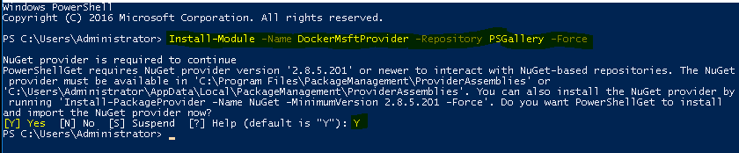

**Step 2:Install Docker Packages**

# Install-Package -Name docker -ProviderName DockerMsftProvider

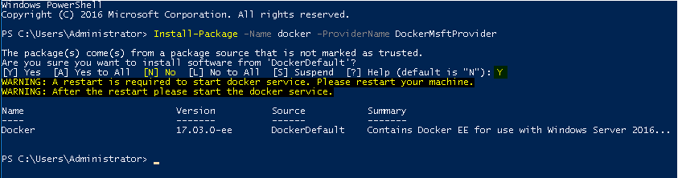

**Step 3:Restart the Windows Server**

# **// Restart the Windows Server**

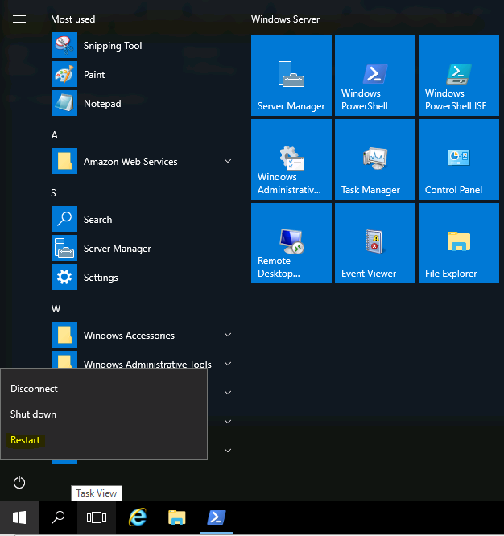 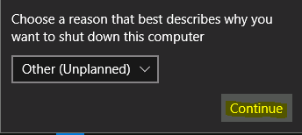

**Step 4:Check for the Docker information(Weather it is install successfully or not)**

# docker info

